Collin Coviello
Cell Biology
Dr. Priyanka Roy
6 April 2018

Slide Analysis for Lab 9: Immunohistochemistry of Tubulin

Lilium Anther, First Meiotic Division
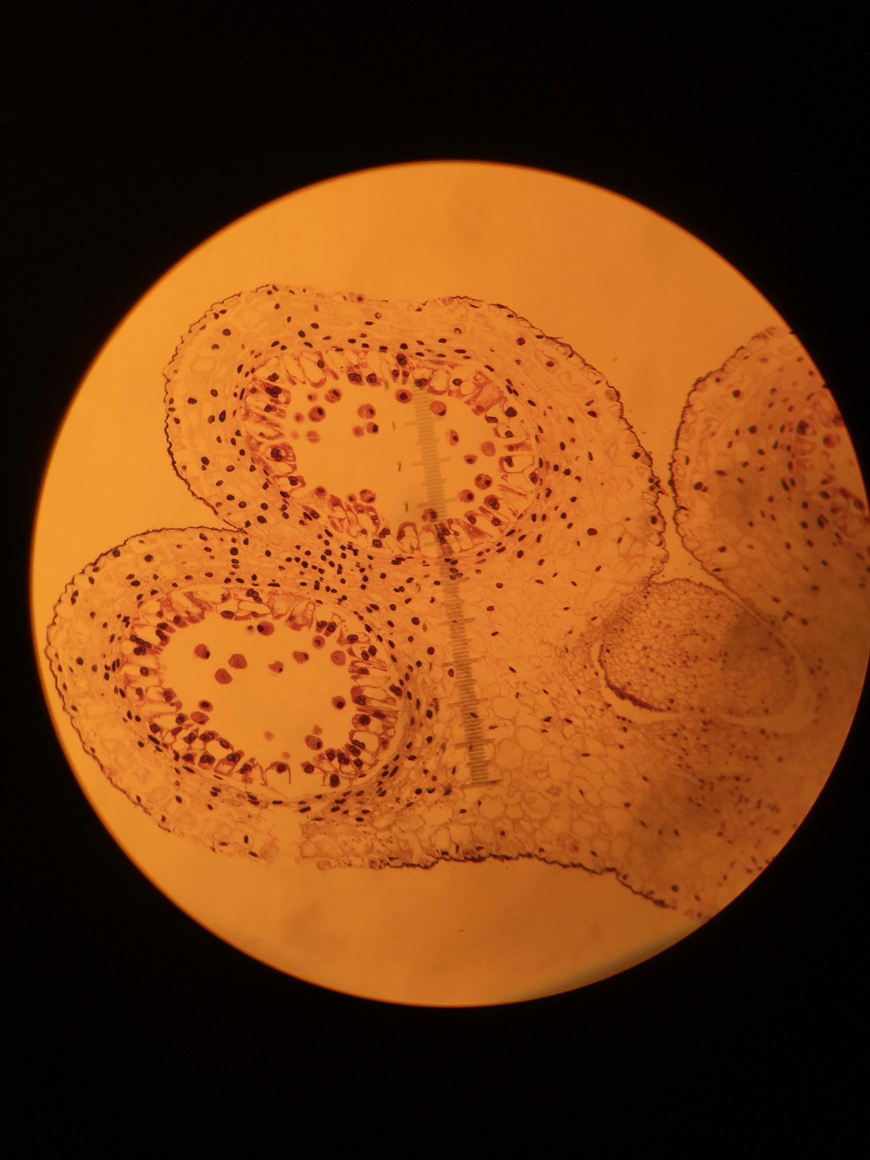
This slide shows the creation of two daughter cells, and the two distinct centers which are created as a part of the creation of pollen cells in this lilium anther.

Lilium Anther, Second Meiotic Division
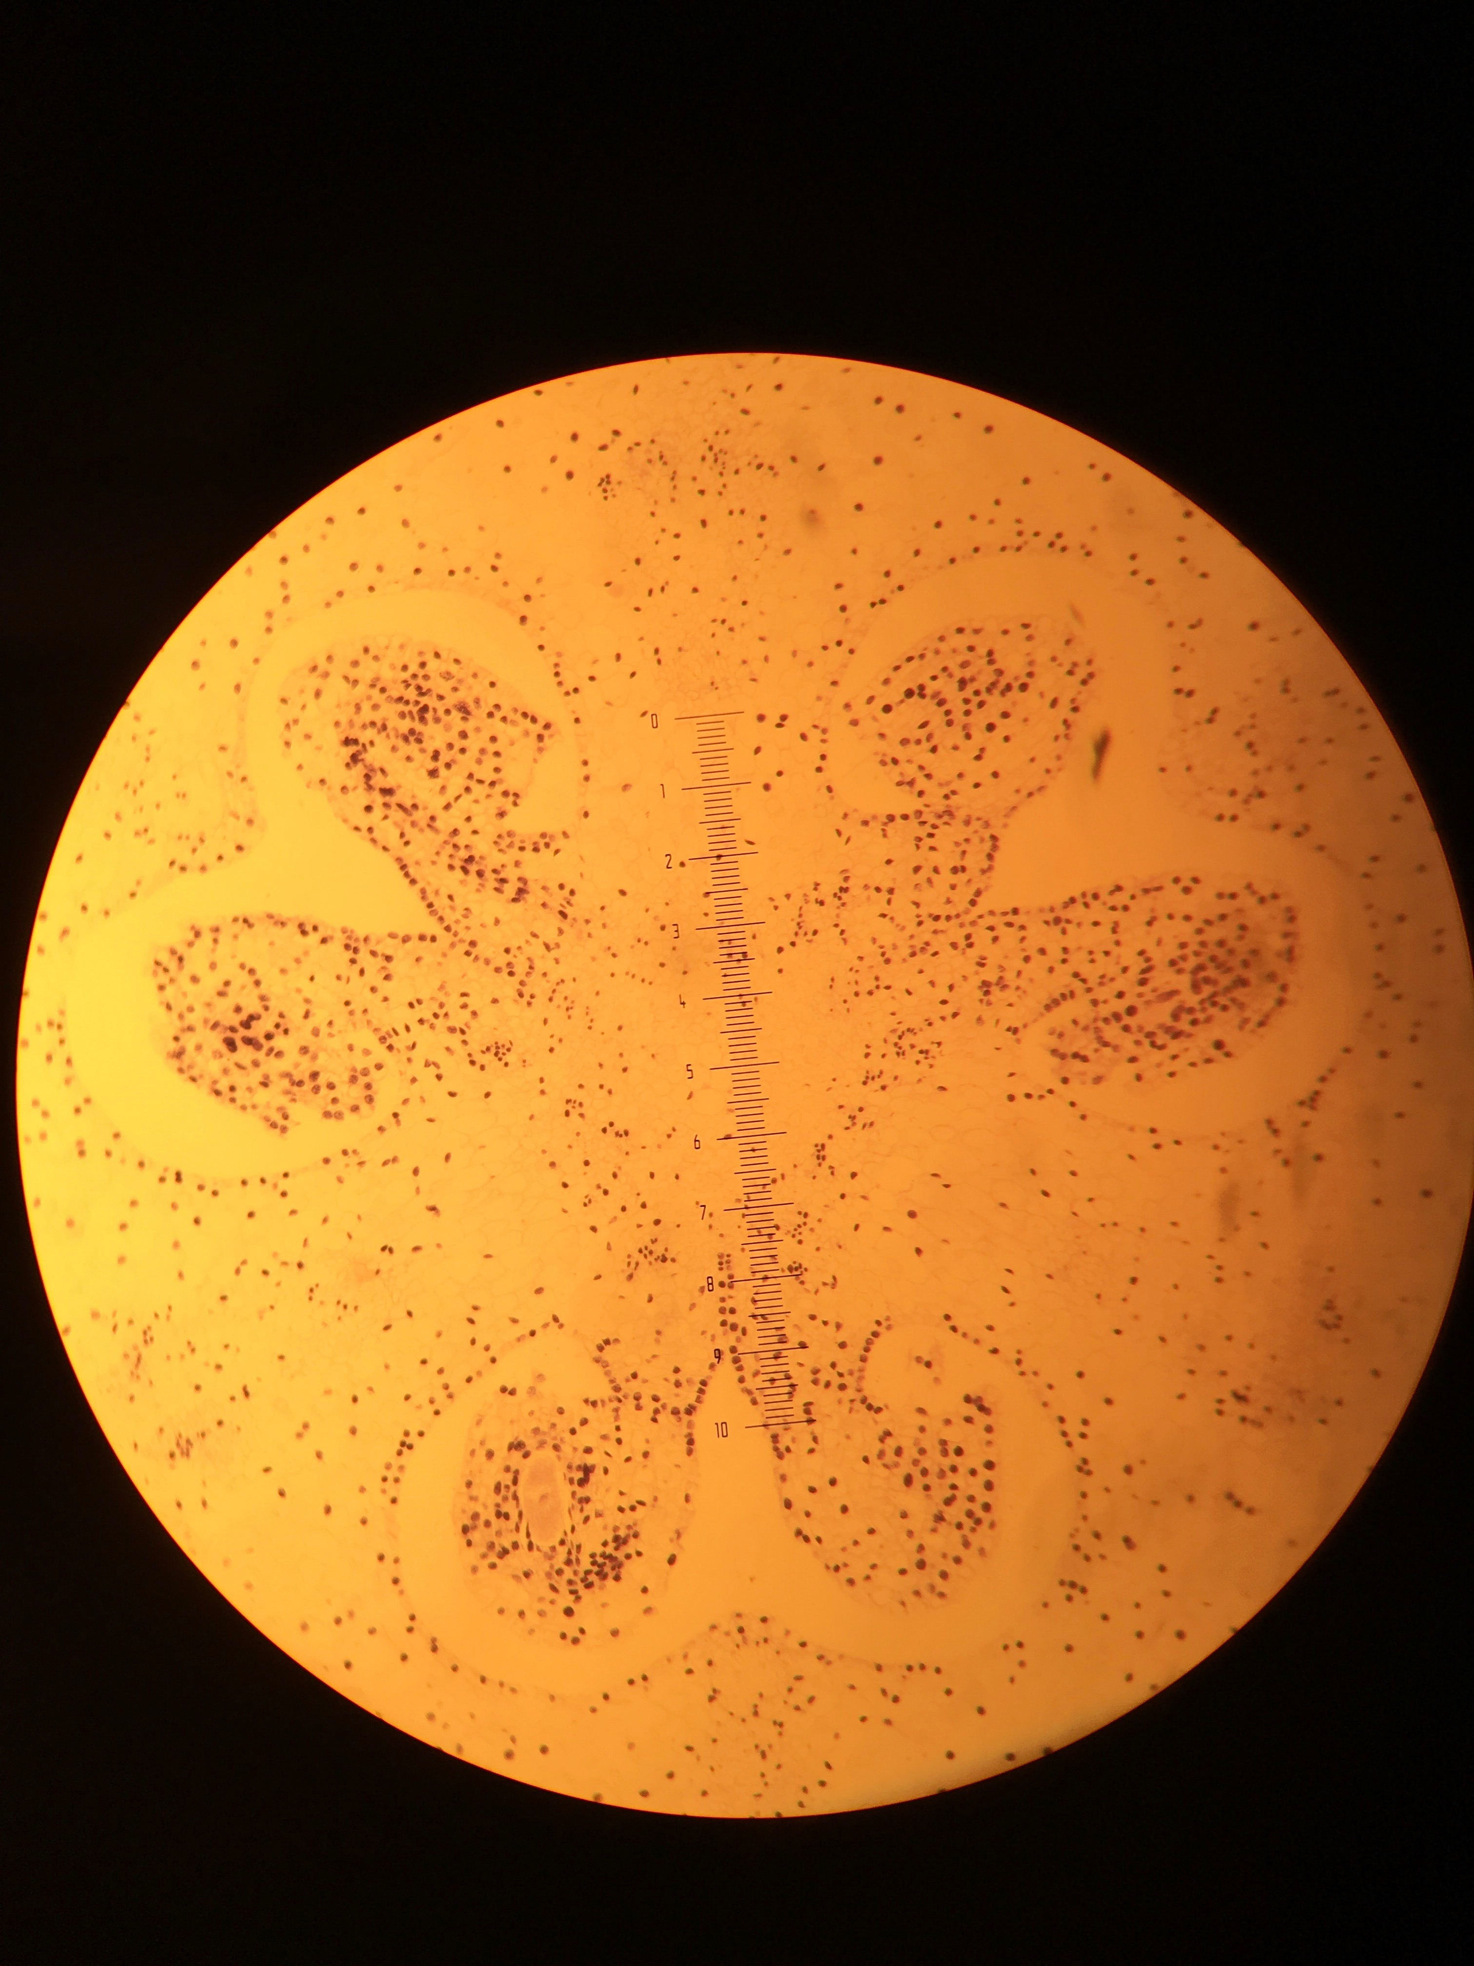
The dye that stained the nuclei is showing the several daughter cells differentiating into gametes. The proteins are being divided into different cells and all of the cytoplasm is divided up as well.

Lilium Anther, Third Meiotic Division
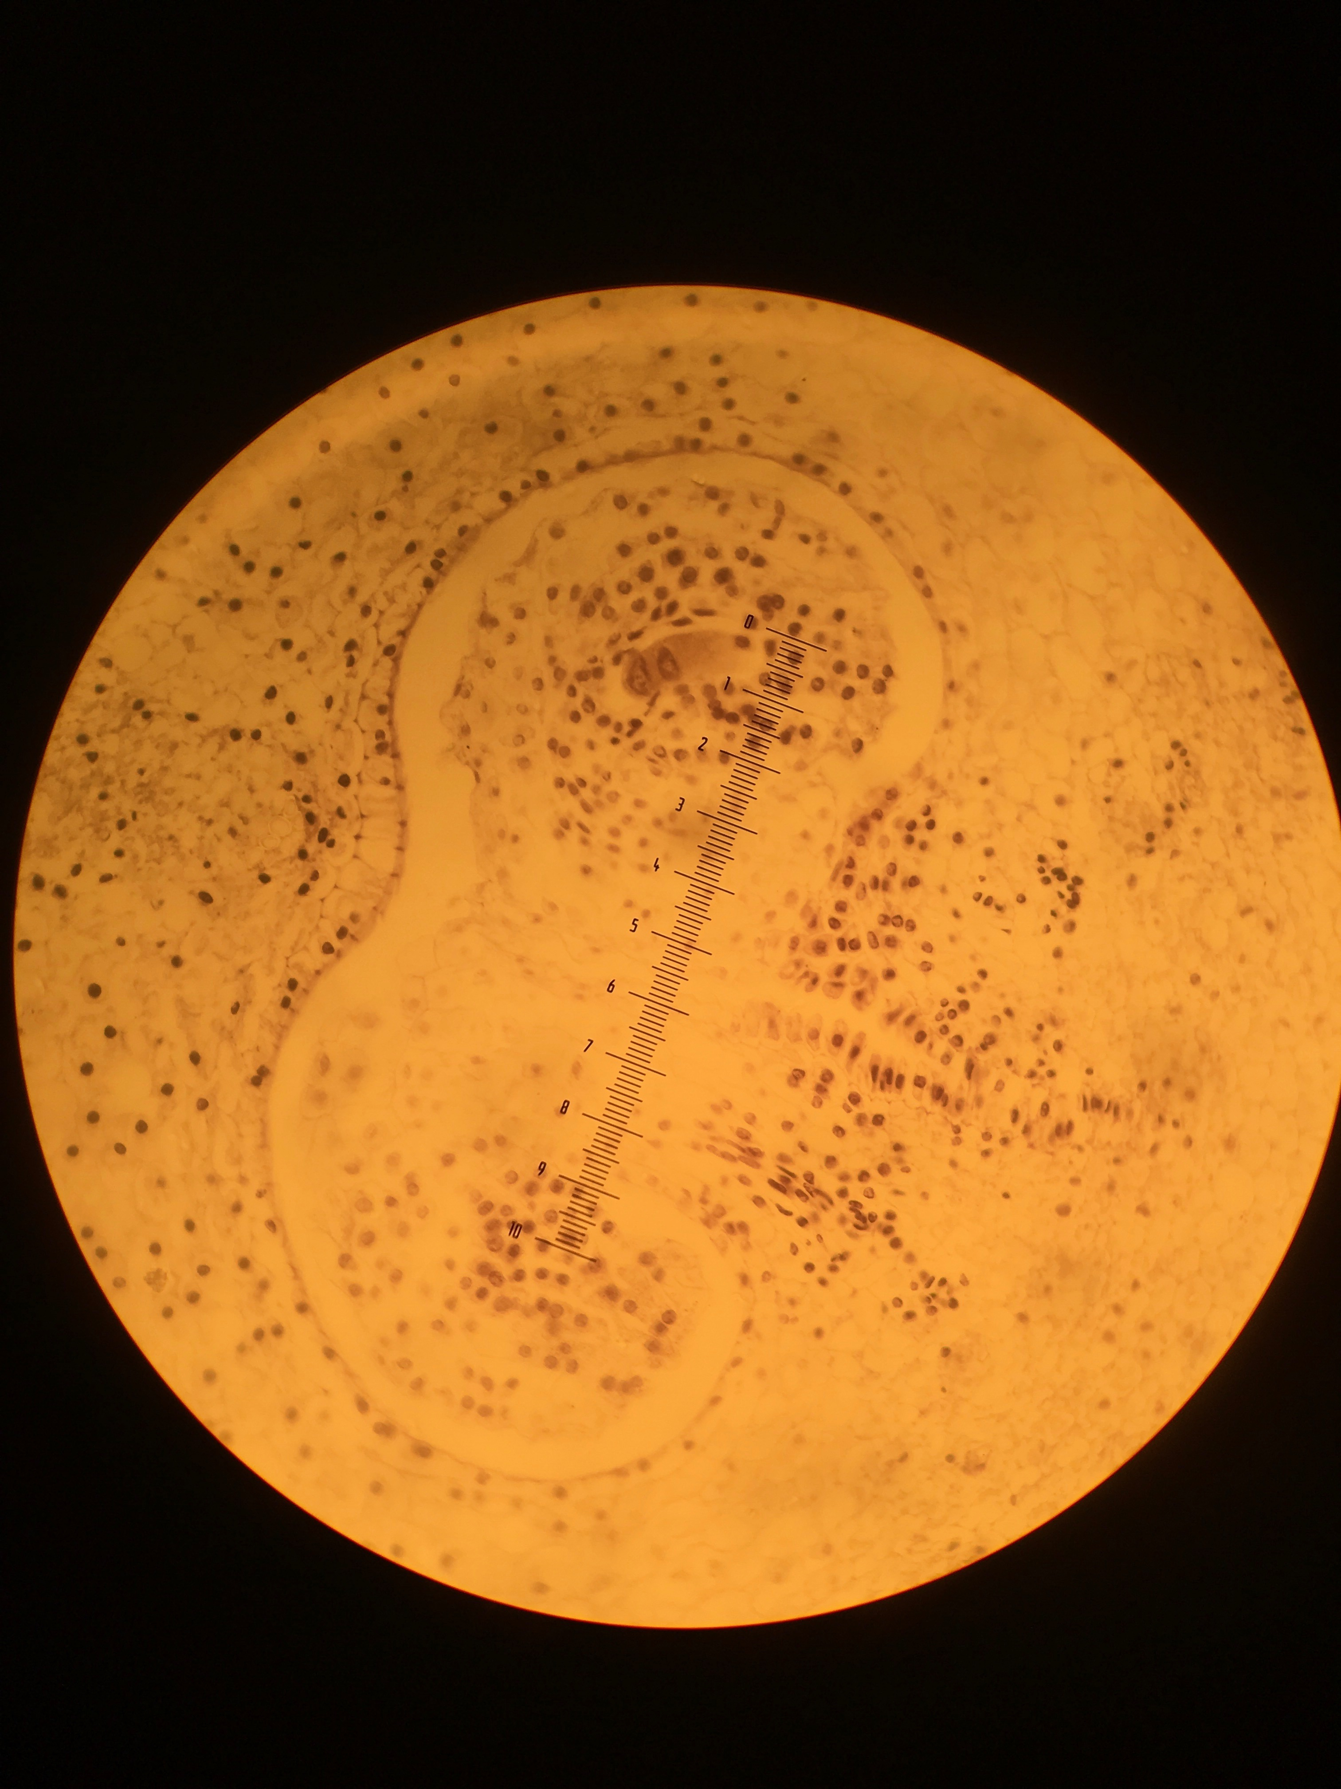
The two daughter cells that resulted from the second division are shown here which continue separating. With the help of cell division proteins, cytokinesis occurs, which can be seen in the purple towards the left of this slide showing the third meiotic division.

Immunohistochemistry Slides
Group 1: The staining of the antibody of alpha tubulin
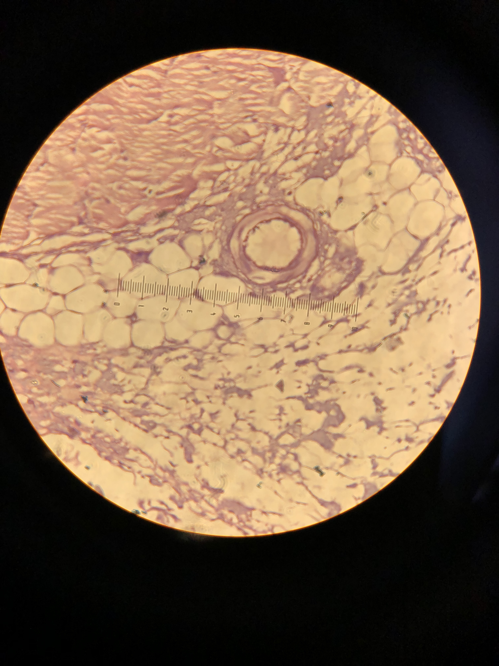
This slide is showing a tracheal cell will all kinds of tubulin, which was clearly helping the cells, move through the mucus. The different and distinct boundaries of the cells were highlighted, which would indicate that this protein is very present where the structure of the cell is specific.

Group 3: Hematoxylin and eosin stain to show other parts of tracheal/esophageal cells 100x
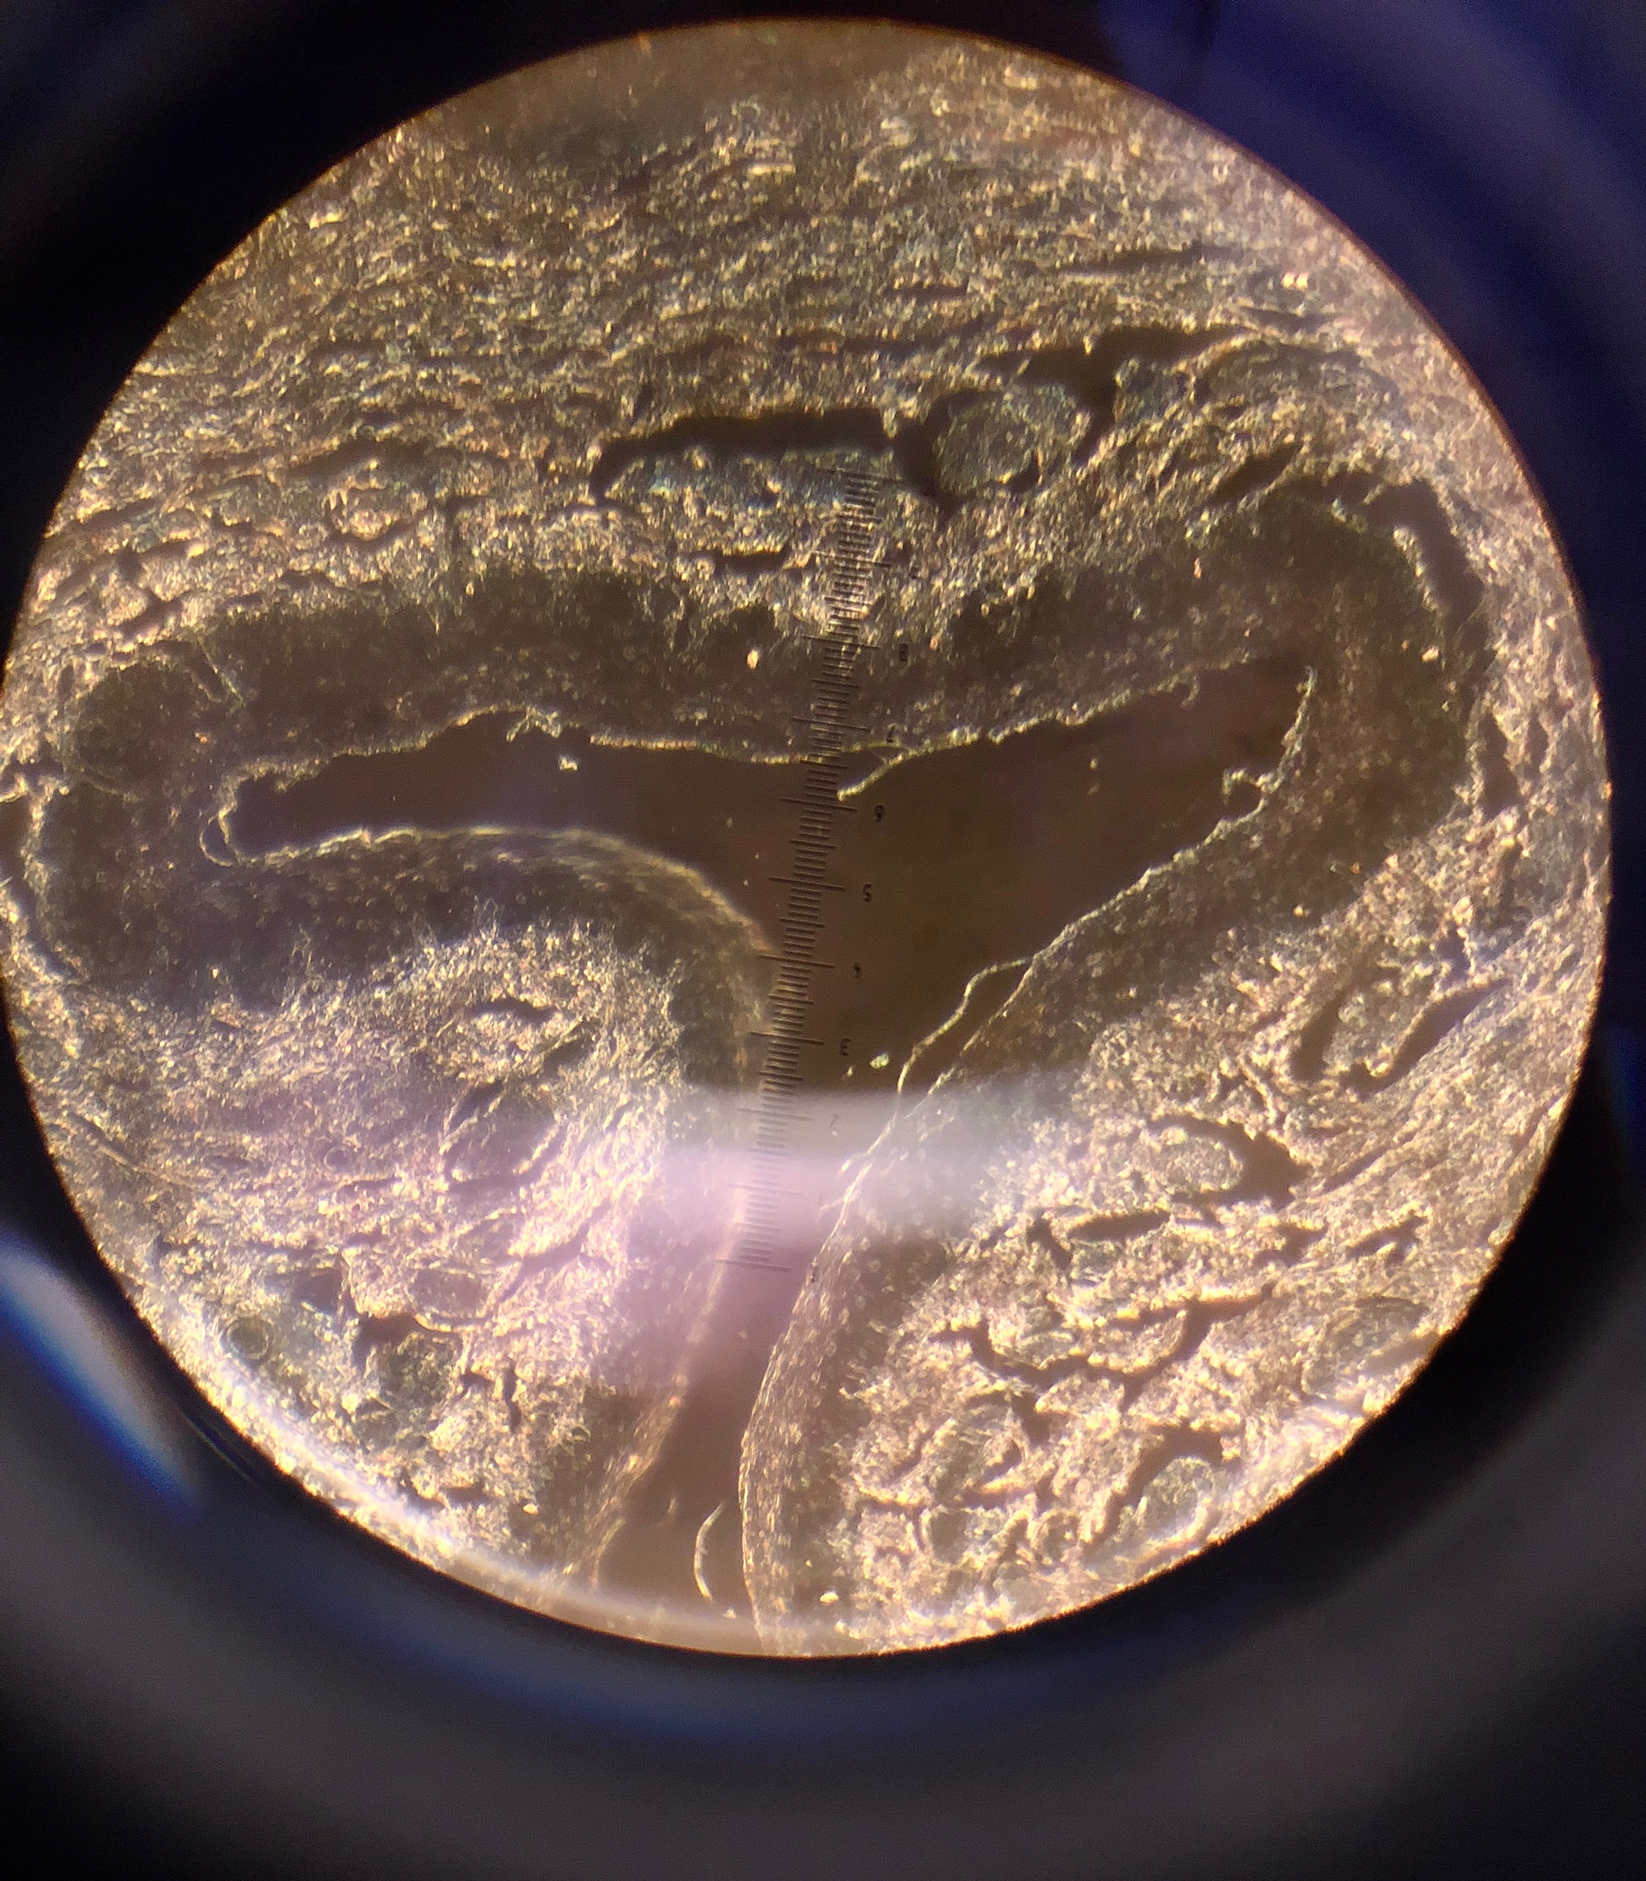
In this slide, the esophagus epithelium is highlighted by the dye. The circular muscle of the cell is made with multiple layers of cells, and those closest to the lumen are squamous cells.

