Collin Coviello

BIO-311 Genetics

Dr. Loren Launen

28 April 2018

Phylogenetic Tree

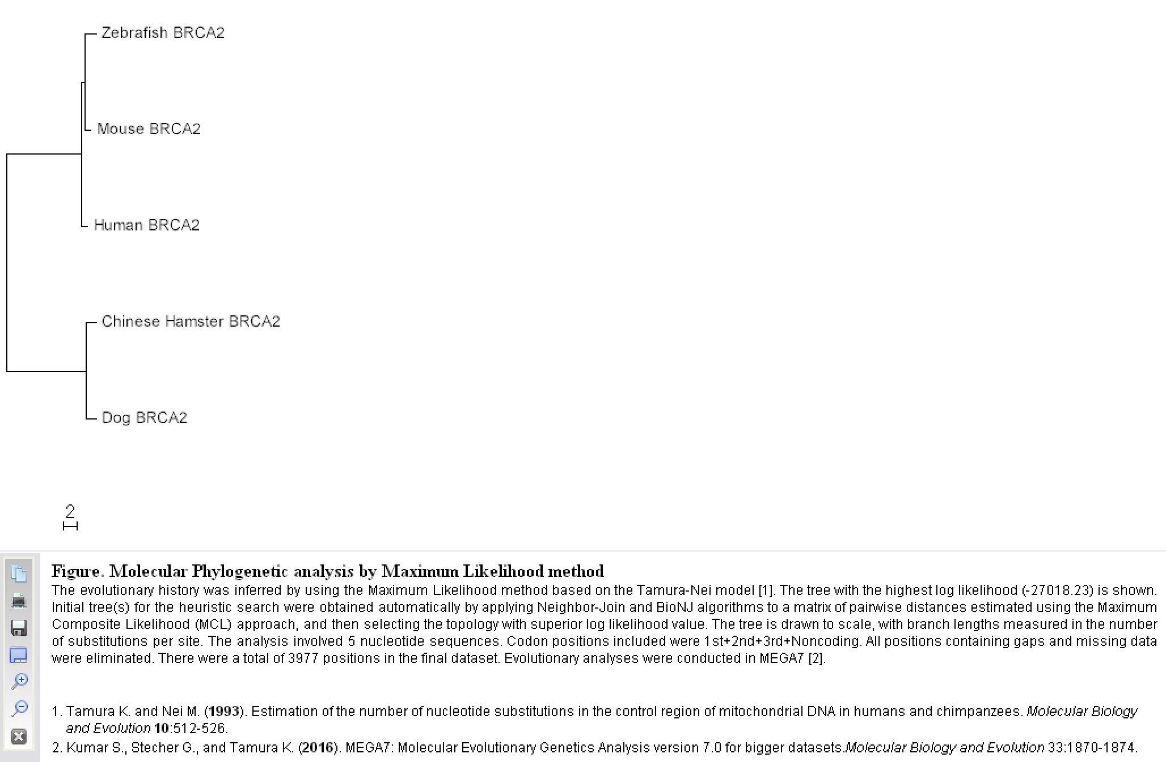

This phylogenetic tree shows the BRCA2 gene that has been linked with a susceptibility to Breast Cancer. It is traced through different families of organisms, in this case mostly model organisms, and separates by finding the organisms with the closes matches with concern to the location on the chromosome to the actual nucleotides. The software MEGA was used to build this tree using the Maximum Likelihood method. Each “leaf” on the tree gets connected to each other based on which ones are most likely to have evolved from the others.