Collin Coviello

Plant Biology

Dr. Hays

16 November 2018

**Selective pressure, and its effect on density of petiole trichomes in juvenile *B. rapa***

**Overview:**

Some traits that plants express throughout their life can be genotypically related, and some are phenotypically plastic, and respond to certain stimuli. In the case of this experiment, trichome density was examined in juvenile *Brassica rapa* (wild mustard) plants. If the trichome density of the younger plants would respond to selective pressure, and the distribution of the histogram showing trichome density would shift to have higher values.

**Hypothesis:**

One can induce a higher rate of trichome production in a population by selectively breeding individuals that have a high trichomal density on their petioles with one another.

**Experimental Design:**

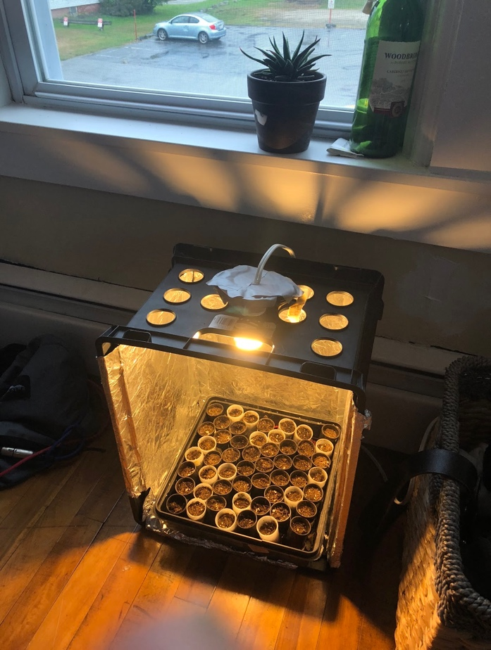

Figure 1. This image shows the F1 generation, “potted” on 9/24 into film canisters containing a seed (“Brassica rapa”), soil, and a piece of felt.

Figure 1 shows the set-up for this experiment. Every plant was put into a separate film cannister which contained soil, and a small piece of felt. The felt extends to come out the back of the film canister, and onto the surface of the top of the two-tiered tray. This top layer is covered with a sheet of felt, and underneath, it has sections of rope that are thread through it. These mechanisms all help the plants indirectly pull water from the tray below, which is kept full at all times. The plants live in a milk crate that has a fluorescent bulb inside that feeds the plants constantly with light energy.

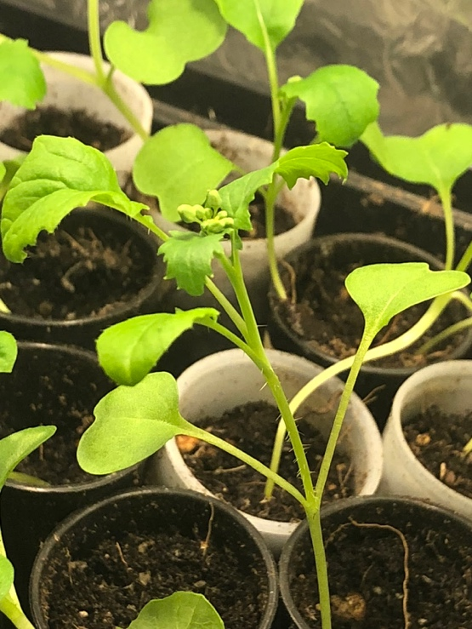

Figure 2. This image shows the phenotype of the presence of trichomes on the petiole. These have their first true leaves. The avg amount of trichomes per petiole was used as the measurement for trichome density.

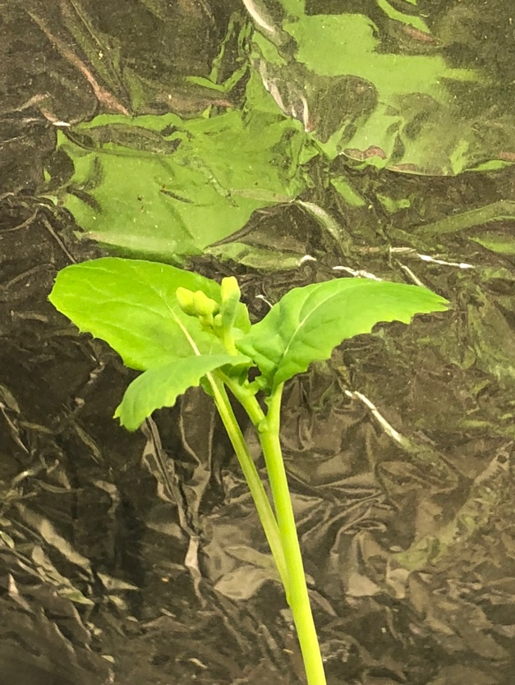

Figure 3. This phenotype of” B. rapa” has no trichomes on it’s petioles.

As seen in Figure 2, and in Figure 3, there were two distinct classes of phenotypes, where some showed trichome growth on the petioles, and some did not.

There also seem to be phenotypes that can differentiate by size, where some are over 6 inches tall, and some are under 6 inches tall. This last picture shows the buds starting to bloom after 17 days. This was not a factor when mates were chosen.

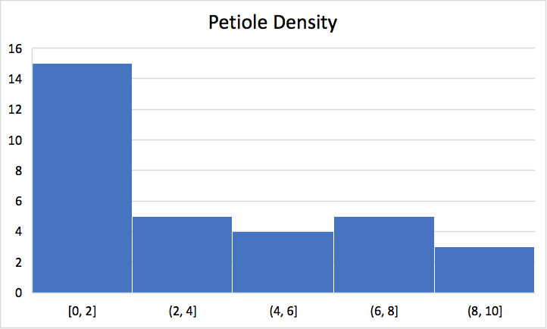

Figure 4. This is a histogram showing the relative frequency of petiole distribution among plants in F1 generation.

Plants were selected for higher trichome density and bred with other plants with higher trichome density to show the trait’s response to selective pressure (1). A normal horse-hair paint brush was used to take pollen from the dehiscent stamen of the male parts of the first plant and brushed onto the stigma of the plant it was meant to be crossed with. Between each pollination, the paintbrush was changed with another identical paintbrush.

Plant F1.9 (4 trichomes/petiole*) was crossed with F1.17 (6 trichomes/petiole*)

Plant F1.2 (6 trichomes/petiole*) was crossed with F1.13 (10 trichomes/petiole*)

Plant F1.1 (8 trichomes/petiole*) was crossed with F1.10 (8 trichomes/petiole*)

Plant F1.31 (6 trichomes/petiole*) was crossed with F1.25 (3 trichomes/petiole*)

*Trichomes were counted across 4 different petioles in juvenile plants, and was averaged

to attain the final trichomes/petiole measurement.

These crosses were done to see if the variation would increase the number of petioles. In other words, is the trait dichotomous, or does the amount of trichomes in the offspring depend on the combined amount of trichomes of both parents. Hidden genetic variation could allow two parent plants with a lower number of trichomes to give offspring with a higher number.

Not to mention, the trichome density of a plant could be a result of the presence of herbivores in the environment of the parents, so that is another possibility for where the variation is coming from (3).

The parent plants were put into pots individually once pollination was complete (1). Then, the plants received self-pollination as a control (Plant F1.20), to make sure the plant cannot self-pollinate. Plant F1.20 showed no growth of seed pods.

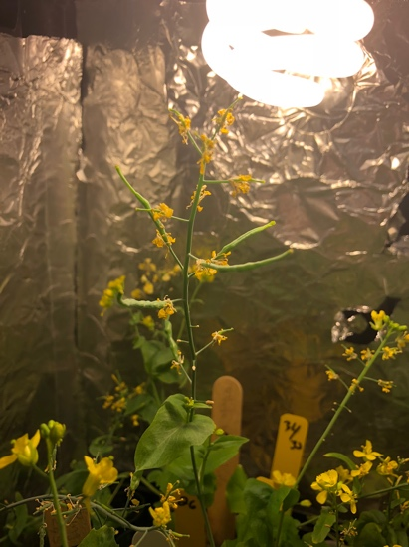

Figure 5. The seed pods developed over a two-week time period in the plants which were pollenated.

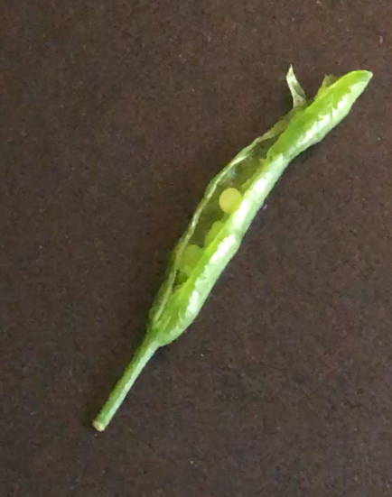

Figure 6. The seed pods were harvested slightly too soon, and the funiculi were still attached to each developing seed. They were all harvested at the same time, in order to keep an aspect of control, but none of them ended up showing any growth after 1 week.

The three treatment groups for the different traits were laid out in new trays, and randomly assorted in their own film canisters, and run in triplicate.

Unfortunately, when the seeds were actually harvested from the different plants that were bred together, they were harvested prematurely, and none of the seeds ended up growing. This can be seen in Figure 6. They had not yet entered the vegetative state (as was discussed in lecture) so the cotyledons were not ready to sprout out of the seed. The time constraint of an experiment for a 1 semester class did not help.

It is hard to tell how this study would have turned out, and if the selective pressure really would have rendered a higher trichome density in subsequent generations.

Differential Induction of Trichomes by Three Herbivores of Black Mustard by M. Brian Traw and Todd E. Dawson talks about the differentiation of *Brassica nigra* in response to different herbivores. It measured the sinigrin concentration and the leaf trichome density (3). This paper shows that the trichomes on the leaves can be dictated by environmental or biotic factors, rather than just being hereditary in nature (3).

However, another paper that was published in June of this year describes the relationship of a gene (*nsLTP*) and trichome density in a different *Brassica* species. This paper shows that we can indeed selectively breed this species to have a certain amount of trichomes. If the budget were bigger, and with less of a time constraint, we could experiment on the expression of that gene based on breeding and based on phenotypic plasticity (2).

**Literature Cited:**

1. Mendel, J. G. (1866). "Versuche über Pflanzenhybriden", *Verhandlungen des naturforschenden Vereines in Brünn*, Bd. IV für das Jahr, 1865, *Abhandlungen*: 3–47. 16 October 2018.
2. Nini Tian, et al. (2018). Overexpression of BraLTP2, a Lipid Transfer Protein of Brassica napus, Results in Increased Trichome Density and Altered Concentration of Secondary Metabolites. *International Journal of Molecular Sciences, 19(6),* 1-22. 16 October 2018.
3. Traw, M., & Dawson, T. (2002). Differential Induction of Trichomes by Three Herbivores of Black Mustard. *Oecologia,* *131*(4), 526-532. 16 October 2018.