Collin Coviello

BIO 311-Genetics

Dr. Loren Launen

28 April 2018

Drosophila Lab Homework

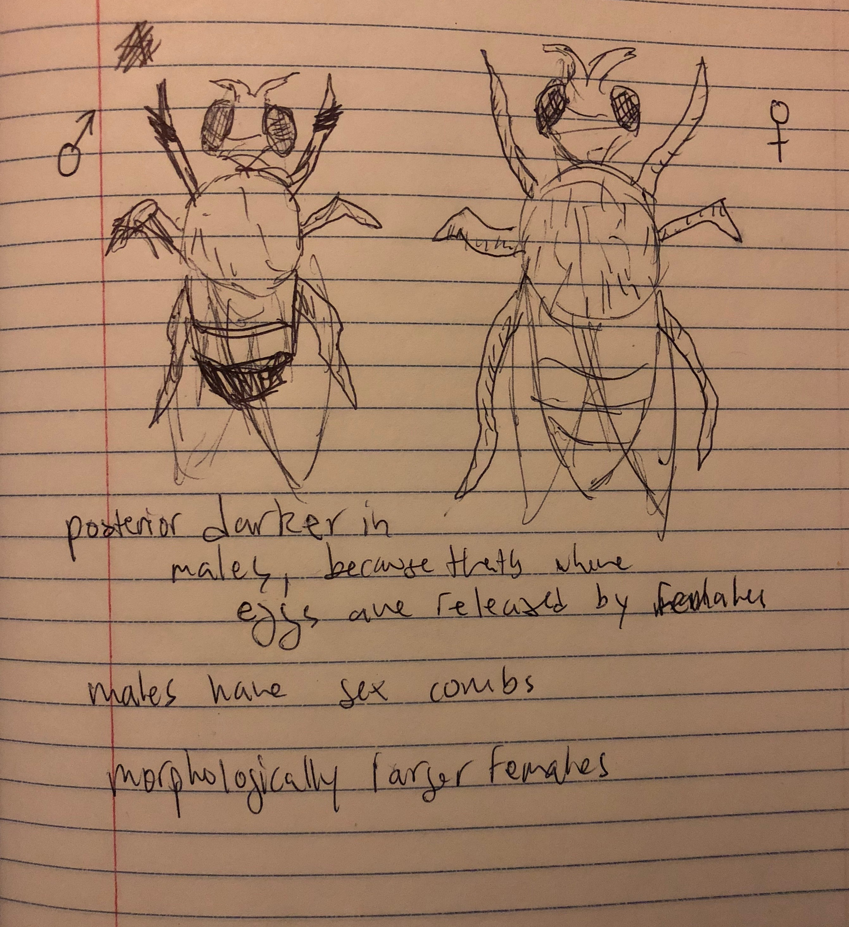

1. As illustrated above, the main differences between the morphology of the male and female drosophila are that the females are generally larger, and they have lighter posteriors. Another thing that makes it easier to distinguish is to notice the presence or absence of sex combs. Males have sex combs, and females do not. Not to mention, the bodies of the females are more pointed at the end.

2. The possible genotypes for a male white-eyed drosophila melanogaster include XwYw ; Ss, and anything where there are not functional proteins made as a result of the X linked genes that control color in drosophila melanogaster.

3. A sepia female would be XWX? ; ss This means that the gene for PDA synthase on chromosome 3 is not coding for the correct sequence of amino acids required to make a functioning protein product.